MEDIA RELEASE: Friday 16 August 2024
Auckland Museum acquires important historical document showing earliest organised attempt at the colonisation of Aotearoa
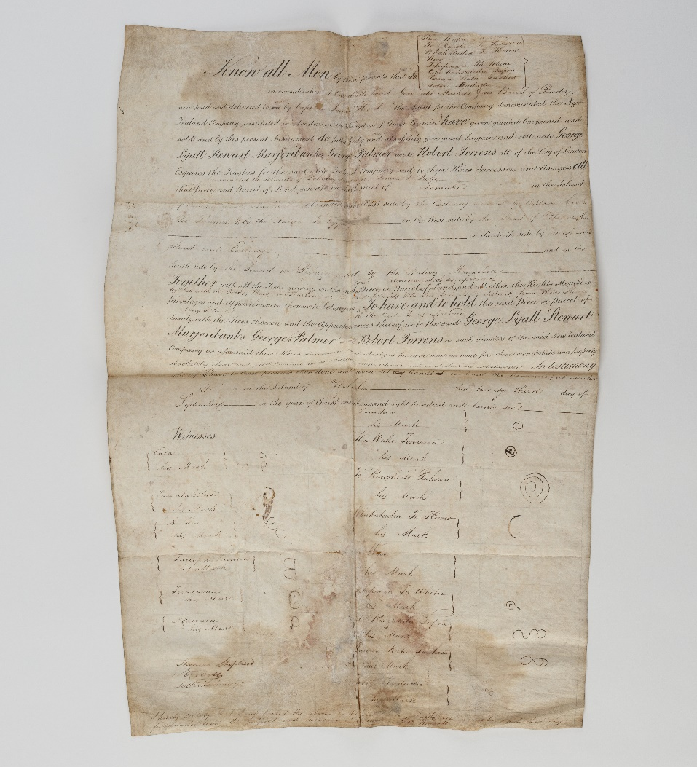
Image: Tuhinga tawhito, Hauraki land arrangement, 1826. Auckland War Memorial Museum Tāmaki Paenga Hira. MS-2024-1.
Tāmaki Paenga Hira Auckland War Memorial Museum has acquired a document that records the first organised attempt to colonise Aotearoa. Importantly for Auckland Museum, this attempt was in the Auckland region.
The nearly 200-year-old document, dated 23 September 1826, surfaced at a London auction in March this year. Following its purchase and several months of meticulous planning for safe transportation, the document has now returned to Aotearoa for the first time in nearly two centuries.
Auckland Museum Tumu Whakarae Chief Executive, David Reeves says the Museum was interested in purchasing the document in-part due to its connection with Tāmaki Makaurau. “Most people probably don’t realise that the first attempts at British settlement in New Zealand included an attempted purchase of islands in the Hauraki Gulf,” says Reeves. “Bringing this document home to Aotearoa, and to Tāmaki Makaurau specifically, will provide opportunities for education and discussion about this significant part of our history. We are especially looking forward to connecting with, and working alongside, descendants of those who signed the document two centuries ago, including Ngāti Pāoa.”
Reeves continues, “Others also saw the significance of this document, and the Museum’s acquisition was made possible thanks to support from three generous private donors who contributed the entirety of the purchase price at auction. We are extremely grateful for the support of these donors.”
The provenance of the document traces it to the Rosanna, which made landfall at Pegasus Harbour, Stewart Island on 5 March 1826. The ship, owned by the first iteration of the New Zealand Company, was carrying 60 perspective settlers. The skipper, Captain James Herd, had been tasked by the directors of the New Zealand Company with surveying the land, exploring trade prospects, and identifying sites for potential settlement.
The group made their way north, arriving in the Hauraki Gulf in late 1826. On 23 September, while anchored off the coast of Waiheke Island, an exchange was made – for one double barrel gun, eight muskets and one barrel of powder – the representatives of the New Zealand Company attempted to buy four islands in the Hauraki Gulf in the “district of Tāmaki”: “Paketu, Taratoia, Ponue and Pake” (correctly known as Pakatoa, Rotoroa, Ponui and Pakihi), including “all the trees growing…with the creeks, bays and harbours on the said Islands & sea three miles distant from their shores.”
The document records an agreement made with eight Māori rangatira and witnessed by 15 Māori rangatira, 14 of whom signed with their moko. This document is one of the earliest known examples of moko signatures. Research is ongoing into the identities of these tupuna.
The land arrangement document had been held by the Lyall family for nearly 200 years. George Lyall was one of the directors of the first New Zealand Company and is one of the four New Zealand Company names on the document.
Ultimately, no claim was made based on this deed. The expedition was poorly organised and had limited financial support but perhaps most significantly, the Rosanna had arrived on these shores right in the middle of the Musket Wars. After a second attempt at purchasing land in Hokianga, the Rosanna left for Sydney without having established any official settlement.
During research prior to purchase of the document, Nina Finigan, Auckland Museum’s Curator Manuscripts, located two other versions of the land arrangement at Archives New Zealand that were not widely known. Finigan says, “Having this document alongside the two already in the country, which differ in several ways, will enable research into their connection to each other and the processes involved in these early transactions. Having this tuhinga tawhito (manuscript) in Tāmaki Makaurau will encourage new and focused research into this episode of the history of our region.”

For all media enquiries, interviews and images contact
Samantha McKegg, Publicist, Auckland War Memorial Museum
smckegg@aucklandmuseum.com | +64 21 458 353

ABOUT AUCKLAND WAR MEMORIAL MUSEUM
Auckland War Memorial Museum is one of New Zealand's first museums. The Museum tells the story of New Zealand, its place in the Pacific and its people. The Museum is a war memorial for the province of Auckland and holds one of New Zealand's top three heritage libraries.
It has pre-eminent Māori and Pacific collections, significant natural history resources and major social and military history collections, as well as decorative arts and pictorial collections.

