Media Release | Thursday 27 June 2024

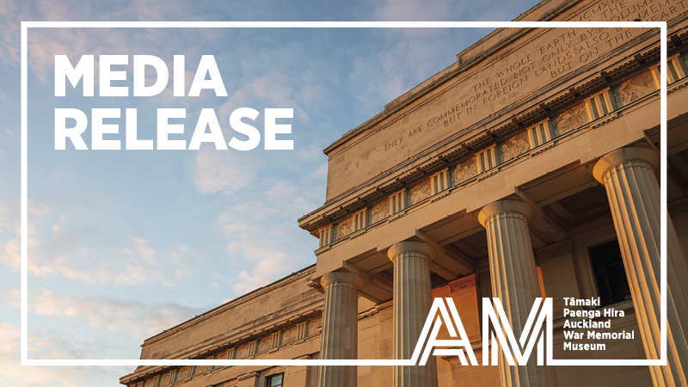

Tāmaki Paenga Hira acknowledges contributions of outstanding individuals in cultural and natural heritage fields

The prestigious Museum Medals were presented at a ceremony hosted at Tāmaki Paenga Hira Auckland War Memorial Museum last night (26 June). The Museum Medals recognise excellence and innovation in the study of our cultural and natural heritage. This year’s recipients have made major contributions to their areas of study and the creation of new knowledge, or in service to the Museum.

Winners of this year’s Museum Medals were:
- Dr John E. Braggins - Associate Emeritus of Auckland War Memorial Museum
- Dr Susan Abasa - Companion of Auckland War Memorial Museum
- Mary Ama CNZM - Companion of Auckland War Memorial Museum
- Chrstina Hurihia Wirihana - Companion of Auckland War Memorial Museum

Auckland Museum Tumu Whakarae Chief Executive David Reeves says, “At Tāmaki Paenga Hira Auckland War Memorial Museum, research underpins much of what we do and ensures that we continue to explore boundaries and new ways of thinking, creating interpretations of the world around us and bringing fresh ideas to our audiences”

“The Museum Medals recognise individuals who have delivered excellence in the study of our cultural and natural heritage. This year’s recipients have made major contributions to their areas of study and the creation of new knowledge, and it is a privilege to be able to celebrate their achievement with the recognition of the Museum Medals,” says Reeves.

Dr. John Braggins was made Associate Emeritus of Auckland War Memorial Museum for his dedication to the field of botany, and his contributions to plant taxonomy and education. Braggins completed a BSc and MSc at Victoria University of Wellington and, in 1969, he moved to Auckland to work on his PhD while lecturing in botany. Braggin’s early research and collections focused on ferns, a lifelong interest since his youth, and expanded to include a broad range of plant groups. His research areas encompass flowering plants, pollination in native gymnosperm species, ferns (particularly the gametophyte stage), lichens, mosses, and liverworts, resulting in over 70 published papers and reports. In 2000, he received a Robert O. Bass Visiting Scientist scholarship, and in 2013, he was awarded the Allan Mere Award for Meritorious Service to Botany in New Zealand.

Dr. Susan Abasa was made a Companion of Auckland War Memorial Museum, recognising her significant contributions to the museum sector in Aotearoa New Zealand and around the world through governance, research and education. Since the mid-1970s, Abasa has worked in museums, spending two decades in Australia focusing on exhibition management, education, and policy at institutions including the University of Adelaide and Queensland Art Gallery and the Art Museums Association of Australia (AMAA). Joining Massey University in 1996, she became a lecturer and Programme Co-ordinator in Museum Studies, a programme influenced by Māori leaders and known for its innovative distance learning. Abasa has also served in various advisory, governance, and mentoring roles within the museum sector. A graduate of the University of Adelaide and Massey University, she was awarded Honorary Life Membership by Museums Aotearoa in 2024.

Mary Ama CNZM was made a Companion of Auckland War Memorial Museum, recognising her role as a community leader and for contributions to Pacific arts. Ama is a master artist, educator, and community cultural leader born in Rarotonga, Cook Islands. She emigrated to Aotearoa New Zealand in the 1970s, bringing her ancestral arts and knowledge. In the 1980s, Ama founded the Pacifica Mamas, a collective of Pacific artists and knowledge-holders, to create a space for preserving and celebrating Pacific arts and cultures. This legacy continues through Moanaroa (Pacifica Arts Centre) in West Auckland. Ama has shared her cultural knowledge globally through galleries, exhibitions, and museums, including creating the Vaka Fa’aola Arts Programme for Pacific prison inmates and participating in the Pacific Collections Access Project at Auckland Museum. She received the Creative New Zealand Pacific Heritage Arts Award in 2012, the Arts Access Aotearoa Community Corrections Award in 2015, and was appointed Companion of the New Zealand Order of Merit (CNZM) in 2017 for her services to the arts and Pacific communities.

Christina Hurihuia Wirihana (Ngāti Maniapoto-Raukawa, Ngāti Whawhakia, Ngāti Pikiao) was made Companion of Auckland War Memorial Museum, recognising her outstanding contributions to the preservation and innovation of Māori weaving, as well as her dedication to education and cultural heritage. Wirihana’s professional career spans over three decades, beginning as the first Māori weaver/lecturer appointed at a tertiary institution in 1986. She taught at Waiariki Community College (now Toi Ohomai Institute of Technology), Te Whare Wānanga o Awanuiārangi, and Toi Houkura School of Māori Visual Art and Design. Renowned in New Zealand and internationally for her weaving, Wirihana blends customary and contemporary practices. She is an active member of Te Roopu Raranga Whātu o Aotearoa and has served as its chairperson for six years, and received the Ngā Tohu ā Tā Kingi Ihaka award in 2022.

In addition to the Museum Medals, the AMI Postgraduate Scholarship, and the Sir Hugh Kawharu Auckland Museum Scholarship were also awarded on the night. Auckland Museum Institute Postgraduate Scholarship was awarded to Patricia Pillay, providing support to undertake research aligned to the research priorities of Auckland Museum and its extensive collections. The Sir Hugh Kawharu Auckland Museum Scholarship was awarded to Tāniora Maxwell (Ngāti Whātua, Ngāi Tai, Te Whakatōhea, and Ngāti Awa) to support and encourage Māori research and leadership, particularly in the field of cultural heritage.

The event included a special address from guest speaker Distinguished Professor Jacinta Ruru (Raukawa, Ngāti Ranginui) MNZM FRSNZ, Te Po Koko Māori/Deputy Vice Chancellor Māori, University of Otago.

[ENDS]

Supporting materials including Museum Medal winners bios and images can be found here

For media enquiries, interviews and images contact:
Samantha McKegg, Publicist
Tāmaki Paenga Hira Auckland War Memorial Museum
smckegg@aucklandmuseum.com | +64 21 458 353

