MEDIA RELEASE: Monday 25 March 2024
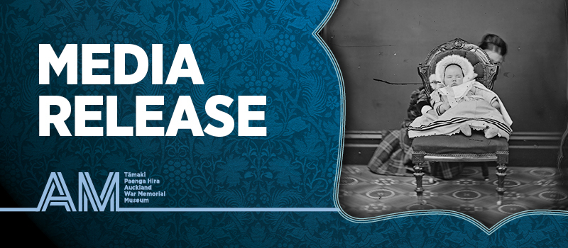
CAPTURING HISTORY: NEW EXHIBITION AT AUCKLAND MUSEUM
EXPLORES TRANSFORMATIVE EARLY PHOTOGRAPHY IN AOTEAROA

Discover the captivating history of photography in Aotearoa in A Different Light: First Photographs of Aotearoa, opening at Tāmaki Paenga Hira Auckland War Memorial Museum on Thursday 11 April 2024.

The first recorded use of photography in Aotearoa was in 1848, less than a decade after it became commercially available in Europe. Over the second half of the 19th century, professionals and amateurs alike experimented eagerly with the new technology and set in motion an image revolution that forever changed the way we see ourselves.

New Zealand’s first photographs reveal Kīngi and governors, geysers and muddy streets, battles and parties. They freeze faces in formal studio portraits and stumble into the intimacy of backyards, gardens, and homes.

Through examples of our earliest photographs, this exhibition traces the advancements and proliferation of photography in New Zealand, from its beginnings as an expensive luxury for a privileged few through to becoming a part of everyday life by the end of the 19th century.

A Different Light brings together photographs and ephemera from the extraordinary and extensive collections of three major research libraries: Tāmaki Paenga Hira Auckland War Memorial Museum, Alexander Turnbull Library at the National Library, Wellington, and Hocken Collections Uare Taoka o Hākena, Dunedin. The exhibition coincides with the release of a new publication of the same name from Auckland University Press, edited by Shaun Higgins and Catherine Hammond.

The exhibition shares some of the oldest and rarest photographs made in New Zealand. The earliest images are expensive, silver-coated daguerreotype portraits that required the sitter to hold their pose for up to a minute. Later in the century came the development of revolutionary sharp images with the gelatin silver process, which when paired with a fast-shutter, could capture Victorian-era subjects in action for the first time. Photography also had an important role in surveying Aotearoa, with mammoth-scale negatives carted up and down the country on horseback, that created some of the first photographic images of the land.

David Reeves, Auckland Museum Tumu Whakarae Chief Executive, Auckland Museum says, “A Different Light is an exciting opportunity to see some of the first photographs captured in Aotearoa New Zealand, from the collections of three major national documentary heritage collections: Auckland Museum, Hocken Collections and the Alexander Turnbull Library. Through our collaboration we are able to present the best examples of early photography in New Zealand and share the research and stories behind these remarkable images.”

Reeves continues, “The advent of photography in the mid-19th century was a remarkable technological event which had significant impacts on society at the time. This exhibition gives us a chance to reflect on that and more recent changes in the way images are captured and shared and what that means for identity, privacy, and connection with each other.”

Shaun Higgins, Auckland Museum Curator Pictorial, explains that this exhibition is the first time many of these images have been on public display: “A Different Light is a unique opportunity to see these rare early photographs together. They are exceptionally delicate, and it is only with carefully controlled lighting and display conditions that we have been able to bring them out and share them.”

Catherine Hammond, incoming Director of Collections and Research at Auckland Museum and publication co-editor, says, “To bring together collections from around the motu means this is a more complete survey of early photography in New Zealand. There are intimate moments from 19th century amateur photographers and some of the first photographs of Māori including portraits of tipuna that hold deep significance.”

A Different Light: First Photographs of Aotearoa is a collaboration between Tāmaki Paenga Hira Auckland War Memorial Museum, Hocken Collections Uare Taoka o Hākena, and Alexander Turnbull Library at the National Library. The exhibition has been co-curated by Shaun Higgins (Auckland Museum), Dr Anna Petersen (Hocken Collections), and Natalie Marshall (Alexander Turnbull Library). Following its time in Tāmaki Makaurau, A Different Light will tour to Adam Art Gallery (Wellington) in February 2025 and Hocken Collections (Dunedin) in September 2025.

For more information, interviews, or images contact:
Samantha McKegg
smckegg@aucklandmuseum.com | +64 21 458 353
A DIFFERENT LIGHT: FIRST PHOTOGRAPHS OF AOTEAROA
OPENS THU 11 APR – SEP 2024. SAINSBURY HORROCKS GALLERY, LEVEL 2.
FREE WITH MUSEUM ENTRY.
MEDIA IMAGES HERE

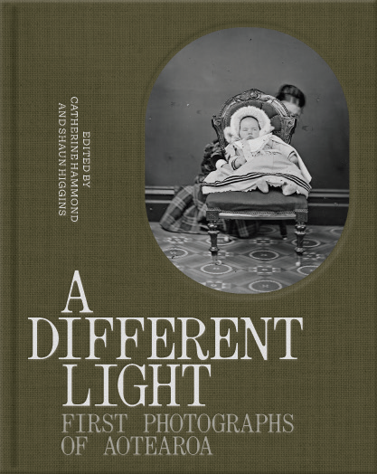
New Publication |
A Different Light: First Photographs of Aotearoa
Edited by Catherine Hammond and Shaun Higgins

Alongside the editors, A Different Light includes essays by Angela Wanhalla, Paul Diamond, Anna Petersen, and Natalie Marshall.

Published by Auckland University Press

Published: 11 April 2024
RRP: $65
ISBN: 9781869409944

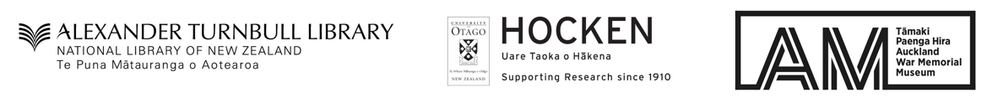

ABOUT AUCKLAND WAR MEMORIAL MUSEUM
Auckland War Memorial Museum is one of New Zealand's first museums. The Museum tells the story of New Zealand, its place in the Pacific and its people. The Museum is a war memorial for the province of Auckland and holds one of New Zealand's top three heritage libraries.

It has pre-eminent Māori and Pacific collections, significant natural history resources and major social and military history collections, as well as decorative arts and pictorial collections.

